1. Laras : Hello, Good evening, mom.

Mother: …………, Laras

1. Good evening
2. Good morning
3. Good afternoon
4. Rizky : Hello, …….Nayla

Nayla : Good afternoon, Nayla.

1. Good afternoon
2. Good morning
3. Good night
4. Bima – is – hi – name – my

The correct senteces is….

1. Hi, name my is Bima.
2. Hi, Bima name is my
3. Hi, my name is Bima
4. hooby – studying – is –my

The correct sentence is….

1. Studying is hobby my.
2. My hobby is studying.
3. My studying is hobby.
4. What is your hobby?

My hobby is……

1. Writing
2. Playing
3. dancing
4. Where do yo live?

I live …… Solo

1. at
2. in
3. on
4. The number is…

twenty

1. 30
2. 20
3. 10
4. 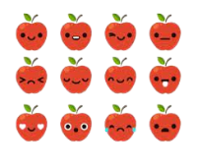There are ……apples.
5. twenty
6. twenty one
7. twelve
8. Before twenty four is ….

23 24 25

1. Twenty five
2. Twenty three
3. Twenty one
4. After twenty seven is…
5. Twenty six
6. Twenty sight
7. Twenty nine
8. A: Are these drawing books?

B: Yes, …..

1. There are
2. These are
3. Those are
4. Teacher : Egi, don’t run in the …..!

Egi : I am sorry, Sir

1. Classroom
2. Schoolyard
3. Field school
4. 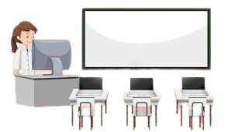A: Is it computer room ?

B: ……..

1. Yes, it is
2. No, it is
3. No, it is not
4. The eggplant is….
5. Gray
6. Orange
7. Purple
8. The tomato is …..
9. Red
10. Blue
11. Black
12. The color watermelon is….
13. Red
14. Black
15. 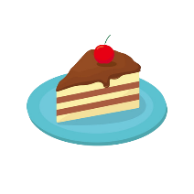Brown
16. This is ……
17. Rice
18. Cake
19. Egg
20. This is ……..
21. Tea
22. Syrup
23. Ice cream
24. 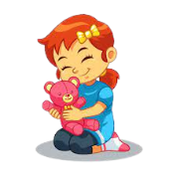She is playing ……..
25. Marbles
26. Skipping rope
27. doll
28. Leni : ……

Noni : I love puzzles.

1. What is your favorite game?
2. How do you play?
3. Where do you play?
4. Zebra
5. Goat